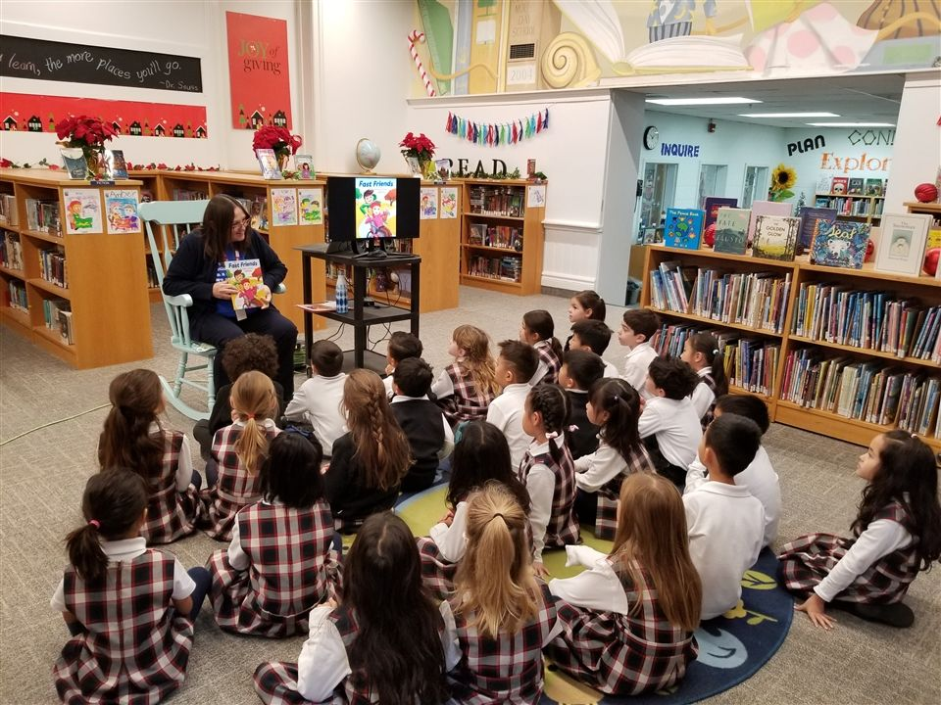

GRADE 1 AUTHOR VISIT WITH HEATHER O'CONNOR
12/2/2022
HILLARY HALL, JUNIOR SCHOOL LIBRARIAN
Our Grade 1 students were filled with excitement to meet award-winning children’s author Heather O’Connor who visited our Junior School Library on Tuesday. Mrs. O’Connor’s picture book, Fast Friends, won the Ruth and Sylvia Schwartz Award and was a finalist for the Blue Spruce Award, the IODE Jean Throop Award, and the Shining Willow Award.
In addition, her book was recently chosen as the TD Grade One Book Giveaway selection for 2022 and every Grade 1 student in Canada is eligible to receive a free copy of Fast Friends through this Canadian Book Centre’s program to promote literacy. Fast Friends was also adapted into a huge colourful animated float that appeared in the Toronto Santa Claus Parade this year!

Our students loved having the opportunity to meet Mrs. O’Connor in person and to learn how she brought the story of Fast Friends alive in partnership with her talented illustrator, Claudia Davila. After a reading of Fast Friends with the students, they had a chance to get interactive playing a fun ‘Emoji’ game with the author where they explored expressing various emotions in dramatic ways.

The Grade 1 students generated lots of thoughtful questions to ask the author about her writing process and where she gets her story ideas. Mrs. O’Connor delighted in answering their queries and took the time to sign a copy of Fast Friends for each Grade 1 student to have as a special memento of their visit together.

